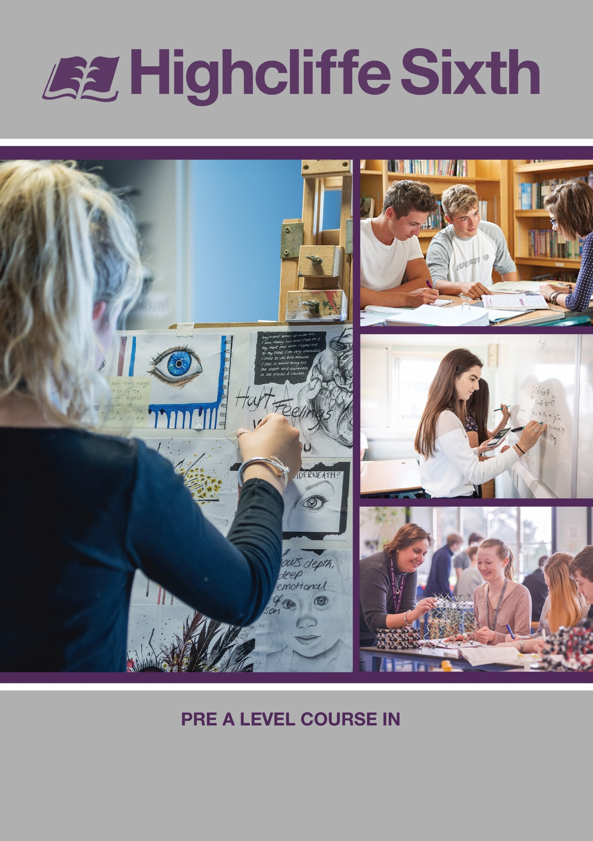

History

A LEVEL History

Course handbook & Pre course tasks 2023/2024

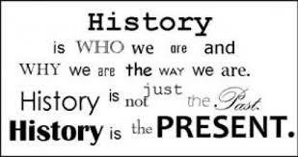

Course outline

A Level History at Highcliffe School follows the OCR exam board specification. Further details about the exact content of the units specified below can be found on this link: http://www.ocr.org.uk/Images/170128-specification-accredited-a-level-gce-history-a-h505.pdf

The course is split into four distinct areas, two of which you will study in Year 12 and the other two areas in Year 13.

How is history assessed?

Content Overview | Assessment Overview
Unit 1: British period study and enquiry.  - The Early Stuarts and the origins of the Civil War 1603-46.  - The execution of Charles I and the Interregnum 1646-60. (Source based enquiry) | British period study and enquiry (Y108)  50 marks  1 hour and 30 minutes paper | 25 %  of total A level
Unit 2: Non British period study  Democracy and Dictatorships in Germany 1919–1963 | Non-British period study (Y221)  30 marks  1 hour paper. | 15 %  of total A level
Unit 3: Thematic study and historical interpretations  Civil Rights in the USA 1865-1992  You will develop the ability to treat the whole period thematically, and to use your detailed knowledge of the depth study topics to evaluate interpretations of the specified key events, individuals or issues. | Thematic study and historical interpretations  (Y319)  80 marks  2 hours and 30 minutes paper | 40 %  of total A level
Unit 4: Topic based essay.  This essay will be based on a topic of your choice related to unit 2 of your studies. | 3000-4000 word essay (Y100)  Non examination assessment.  You will write a 3000-4000 on a topic of your choice related to your Unit 2 study on the Cold War in Asia 1945-1993. This unit is an internally assessed unit. A title proposal form must be submitted to OCR by your teacher to get approval before you  commence your research and write up. | 20%  of total A level

SUMMER TRANSITION WORK

We are so excited to hear that you are hopefully going to be joining us in September to study A Level History.
This booklet will give you a brief introduction to the course layout and help you to start getting to grips with some of the key terminology and ideas in preparation for September.

The first term there are 2 topics we will study. These 2 topics will contribute towards the first 2 final exams you will sit in the summer of Year 13.

These two topics are:

- The Early Stuarts
- Germany Democracy to Dictatorship 1918-1964

Please complete the 4 tasks below and bring this completed workbook with you in September. We have also added some links and information about future Career Pathways in History, with links for you to do some research!
Best wishes, Team History

*SUMMER TRANSITION WORK HAND IN WEEK: 11th – 15th SEPTEMBER

Expectations

- Students are expected to purchase a working file for each unit that they study in order to record and organise any notes and worksheets used in lessons.

- Students are expected to have the correct stationery for the lessons including pens, pencils, scissors, glue and highlighters.

- Students are expected to have the correct textbook with them for each lesson.

- Students are expected to read widely around the topics that they are studying and not just rely on the knowledge acquired from the textbooks or resources their teacher has given them.

- As the lessons involve a lot of discussion based work and exam style questions it is expected that students will complete all home study tasks to a high standard and these must be handed in on time.

- Students are expected to attend all lessons.

- MISSED LESSON CONTENT DUE TO ABSENCE – Students are expected to catch up in their designated study periods (work is shown to teacher upon arrival to the next lesson).

Course textbooks
You may wish to buy the following course textbooks to help you get a head start before September.

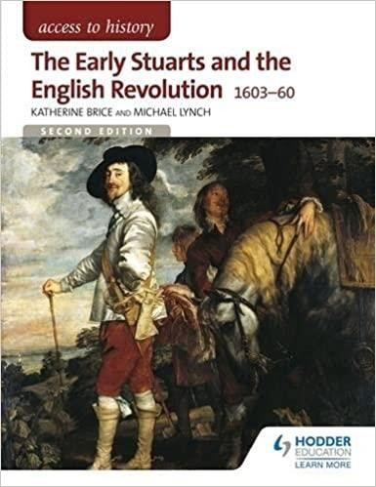For Unit 1: For Unit 2: For Unit 3:
Access to History: The Early Stuarts and the English Revolution 1603-1660 Katherine Bryce and Michael Lynch ISBN: 978-1471838828
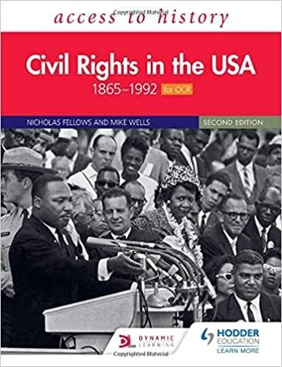Access to History: Democracy and Dictatorships 1919-1963
Access to History: Civil Rights in the USA 1865-1992
Nicholas Fellows and Mike Wells ISBN: 978-1510457935
Geoff Layton
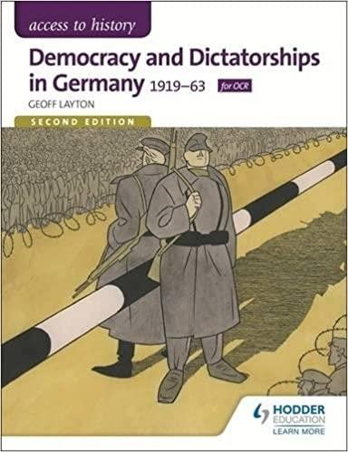
ISBN: 978-1471839153

Task One - Why History?

This is the beginning of your journey to becoming an A Level Historian, what has led you to start this journey?

- Step 1: Watch the videos below:

Greg Jenner on What History Is - https://www.youtube.com/watch?v=dauxQKyIN4M

Greg Jenner is a public historian best known as the Historical Consultant to BBC Horrible Histories, and for his bestselling book A Million Years in a Day and BBC Comedy Podcast ‘You’re Dead to Me’.

Timothy Schnyder on Why History Matters - https://www.youtube.com/watch?v=y-aUTKHeJZc

Timothy David Snyder is an American author and historian specializing in the history of Central and Eastern Europe, and the Holocaust.

Janina Ramirez “How did I get here?”- https://www.youtube.com/watch?v=g6Z19TuH4Zg

Janina Ramirez is a British art and cultural historian and TV presenter, based in Woodstock, Oxfordshire. She specialises in interpreting symbols and examining works of art, within their own historical context.

John Guy “How did I get here?” - https://www.youtube.com/watch?v=RQWXH4E-CcU

John Guy is a leading Tudor historian he has written many books of Tudor history his biography of Mary Queen of Scots was recently adapted into the film Mary Queen of Scots which stars Saoirse Ronan and Margot Robbie.

Laurence Rees “How did I get here?” - https://www.youtube.com/watch?v=TGXDLEevXWY

Laurence Rees is a British historian. He is a documentary filmmaker and author of several books about atrocities committed by the totalitarian states of the Second World War, his series ‘Nazis: A warning from History’ is on Netflix.

- Step 2: Write your new history teachers a short letter about why you have chosen to study A Level History, what you are looking forward to and what you may need help with.

Task Two - Chronology:

During your A Level studies you will be exploring new time periods, topics and themes in both breadth and depth. Understanding the key chronology of your units will be central to your ability to both analyse sources in their context and engage critically and meaningfully with essay questions.

- Step 1: Create a timeline on A3 paper which spans the entire time period you will be studying for each of your two units studied in Year 12. (Two separate timelines)

- Step 2: On your timeline, plot on the key events with full dates and titles.

- Step 3: For each event, can you write a brief description of what happened and the consequences of it?

- Step 4: Can you see any themes, e.g. Finance, Religion? Colour code your timeline

Challenge: Can you now begin to explain the strengths and limitations of timelines? How far, and in what ways, will they be useful to you in studying the past?

An example section of an Early Stuarts and the English Civil War timeline:

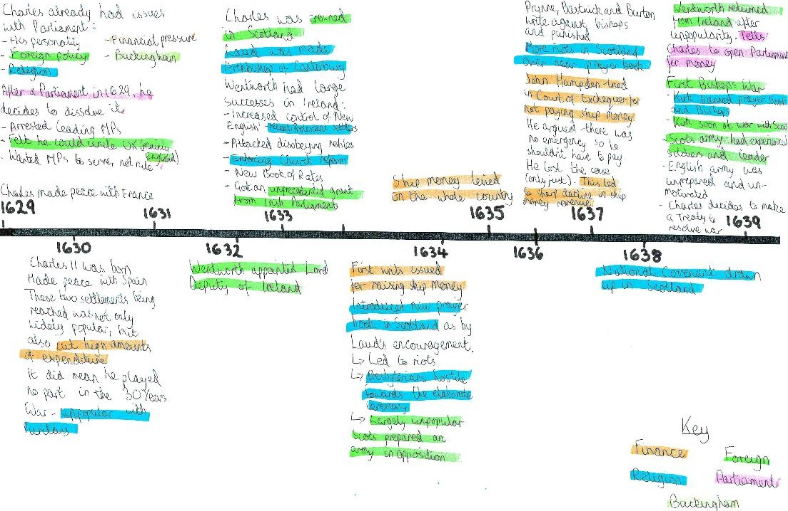

Task Three: - Key People:
One of the central recurring themes in A Level History is the role and significance of individuals in shaping events. Why is it that some individuals are more significant than others? In what ways, if at all, can the contributions of some individuals to the past be unprecedented? In what ways are some events in the past inevitable, unaffected by human agency?
- Step 1: From your timeline, identify 5 key individuals from each of your Y12 units (if in doubt you can email mroberts@highcliffeschool.com to double check the people you have chosen are suitable!). (10 people in total)

- Step 2: For each of your individuals, complete the grid below, explaining the ways that they are significant:

In what ways was this individual's actions or ideas remarkable, both at the time and since? | Why are the actions of this person remembered today and in the past?
What do the actions and ideas of this individual reveal to us about the values and concerns of the time period in which they lived? | In what ways did the actions or ideas of this individual result in short or long term consequences?

- Step 3: Based upon your grids, which of your individuals do you think was most significant and why? If you had to rank them into an order of significance, what would your criteria be for what makes an individual significant in the past?

Stuarts Glossary

Keyword | Definition
Absolute (power)
Act of Attainder
Anabaptists
Anarchy
Apostate
Arbitrary Government
Arminians
Benevolence
Blasphemy
Black Rod
Book of Rates
Church Endowments
Commonwealth
Communion
Franchise
Impeachment
Inflation
Inquisition
Jesuits
Kirk
Masques
Merchant Adventurers
Militia
Monopolies
No quarter
Palatinate
Predestination
Prerogative
Presbyterians
Providentialism
Puritans
Quakers
Recusants
Regicide
Sacraments
Sect
Separatist
Stadtholder
Surplice
Tithes
Tonnage and Poundage
Trained bands
Wardships

Germany Glossary

Keyword | Definition
Allied Control Council
Annexation
Anschluss
Armistice
Aryan
Autarky
Bizone
Blitzkrieg
Comecon
Concordat
Diktat
Ersatzkaiser
Eugenics
Freikorps
Fuhrerprinzip
Gauleiter
Gestapo
Hyperinflation
Kaiser
Lebensborn
Lebensraum
Marshall Plan
Mittelstand
Nationalism
NATO
Operation T-4
Paramilitary Units
Pogrom
Putsch
Reichstag
Reparations
Schlieffen Plan
Social Darwinism
Stasi
Total War
Truman Doctrine
Untermenschen
Volk
Warsaw Pact
Wehrmacht
Weimar Republic
Welfare State
Weltpolitik

Read, Watch, Listen- Unit 1 The Early Stuarts and the English Civil War 1603- 1660
READ
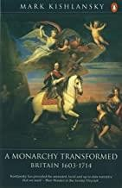
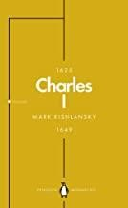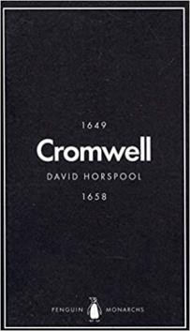

A Monarchy Transformed. By Mark Kishlansky

WATCH

Penguin Monarchs Series
James I – Thomas Cogswell
Charles I - Mark Kishlansky
Oliver Cromwell –
David Horspool

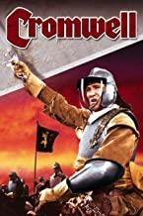

The Stuarts (BBC),
Monarchy with David Starkey,
Cromwell,
The English Civil War (Amazon Prime)

LISTEN

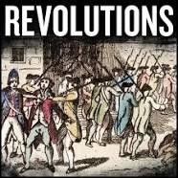
Revolutions Podcast available on Spotify, Apple Podcasts app and: https://www.revolutionspod cast.com/2013/09/001-the- kingdoms-of-charles- stuart.html

In Our Time Podcast available on Spotify, Apple Podcasts app and:
https://www.bbc. co.uk/programmes/b0080xph https://www.bbc.co.uk/programmes/m000g3f6 https://www.bbc.co.uk/programmes/m0001fv2 https://www.bbc.co.uk/programmes/p00546mp

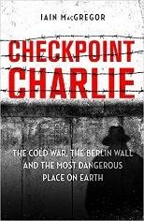
Read, Watch, Listen- Unit 2- Germany Democracy and Dictatorships.
READ

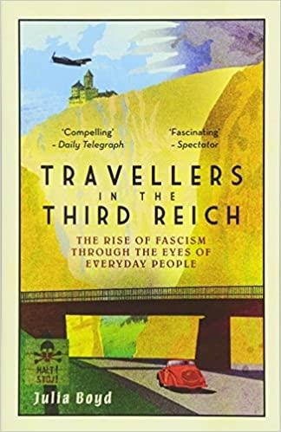
Travellers in the Third Reich: The Rise of Fascism Through the Eyes of Everyday People. By Julia Boyd
Checkpoint Charlie: The Cold War, the Berlin Wall and the Most Dangerous Place on Earth. By Iain MacGregor

WATCH

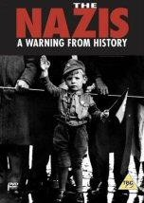
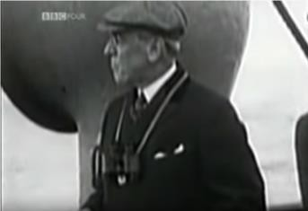
The Nazis a warning from History (BBC)

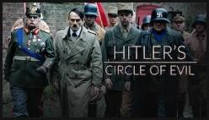
Hitler’s Circle of Evil
(Netflix)

Operation Finale
The Peacemakers TOV Documentary (Youtube)

(Netflix) https://www.youtube.co
m/watch?v=74-HkCRozls

Dan Snow’s History Hit Podcast Episodes:
‘Interwar Germany’s Secret Ally’ 6th Jan 2020
https://www.historyextra.com/topic/nazi-germany/

Careers in History:

Top History Universities:

University of Oxford: University of Oxford | Course Finder (thecompleteuniversityguide.co.uk)

Durham University: Durham University | Course Finder (thecompleteuniversityguide.co.uk)

Warwick University: University of Warwick | Course Finder (thecompleteuniversityguide.co.uk)

Local Universities:

University of Southampton: University of Southampton | Course Finder (thecompleteuniversityguide.co.uk)

University of Chichester: University of Chichester | Course Finder (thecompleteuniversityguide.co.uk)

Careers in History:

